**SUPERIOR UNIVERSITY LAHORE**

|  |
| --- |
| download |

**Faculty of Computer Science & IT**

**FINAL YEAR PROJECT**

**PROJECT PROPOSAL & PLAN**

**[Sarmaya Expert App]**

Project ID: **[write ID here Issued by FYP Manager]**

**Project Team**

|  |  |  |  |  |
| --- | --- | --- | --- | --- |
| **Student Name** | **Student ID** | **Program** | **Contact Number** | **Email Address** |
| Fiza Tahir | Mcsm-f20-053 | MCS | 0333-1453795 | Mcsm-f20-053@superior.edu.pk |
| Iza Tahir | Mcsm-f20-054 | MCS | 0308-9241482 | Mcsm-f20-054@superior.edu.pk |
| Rabia Iqbal | Mcsm-f20-063 | MCS | 0309-9853073 | Mcsm-f20-063@superior.edu.pk |

**[Mr. Muhammad Javaid Iqbal]**

**Code:**

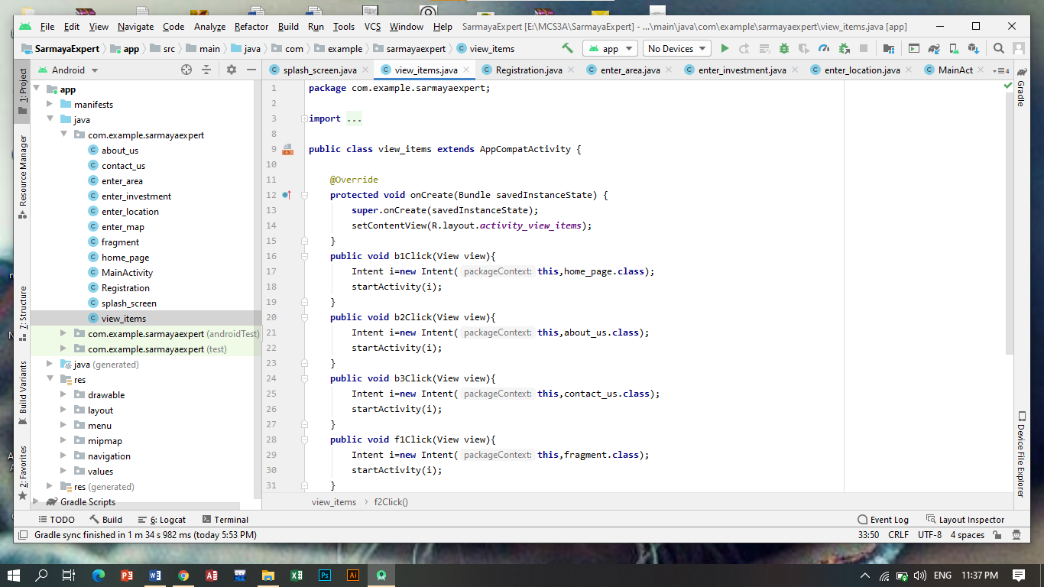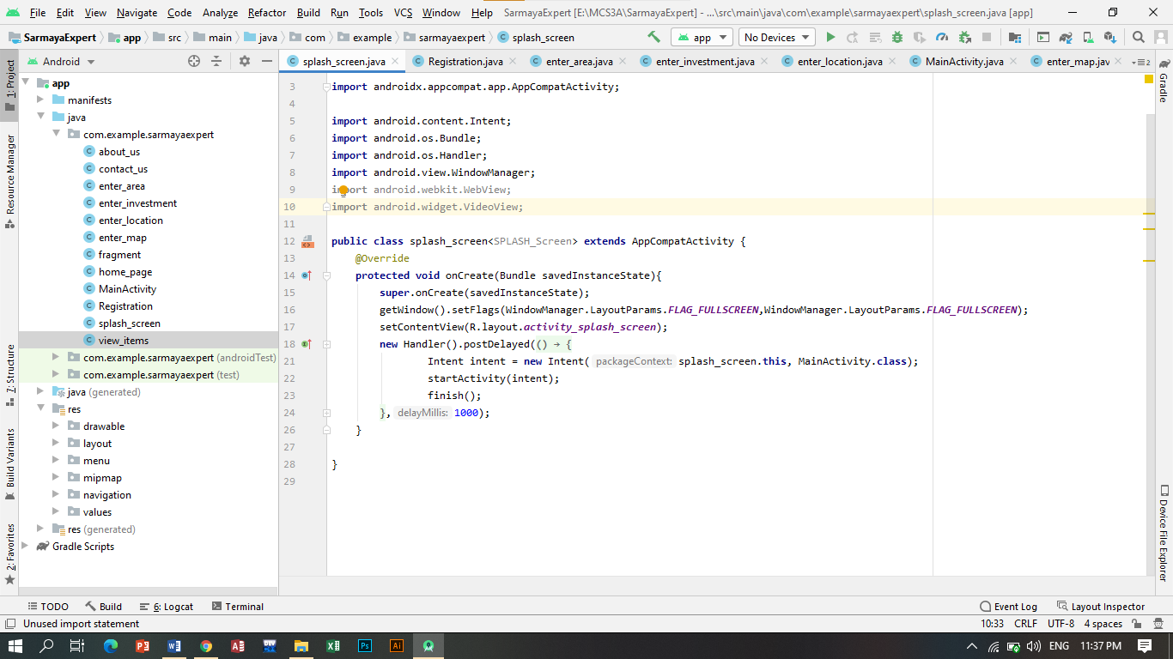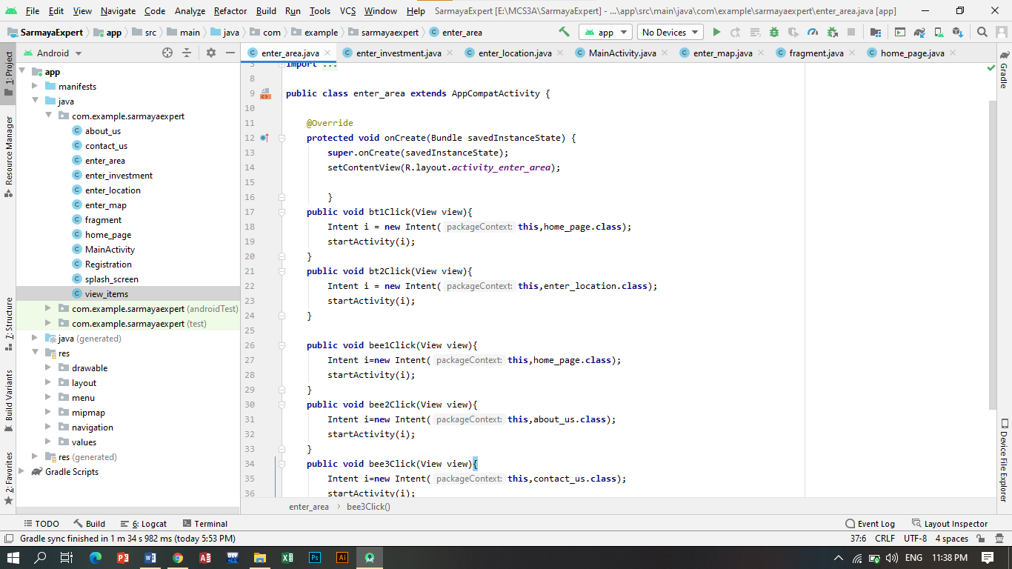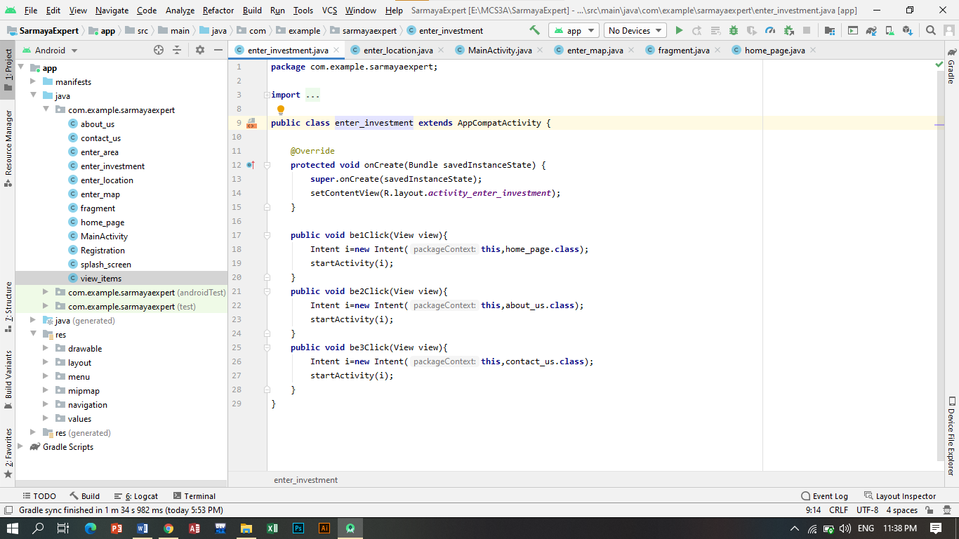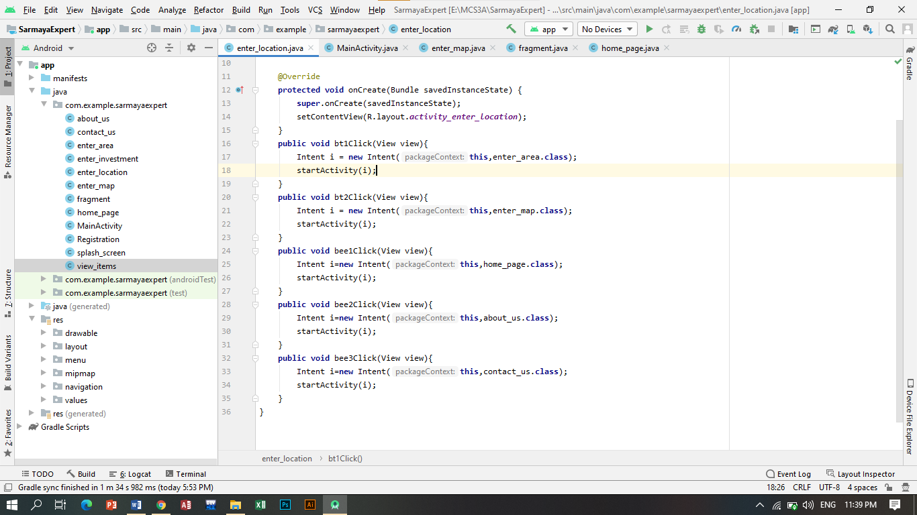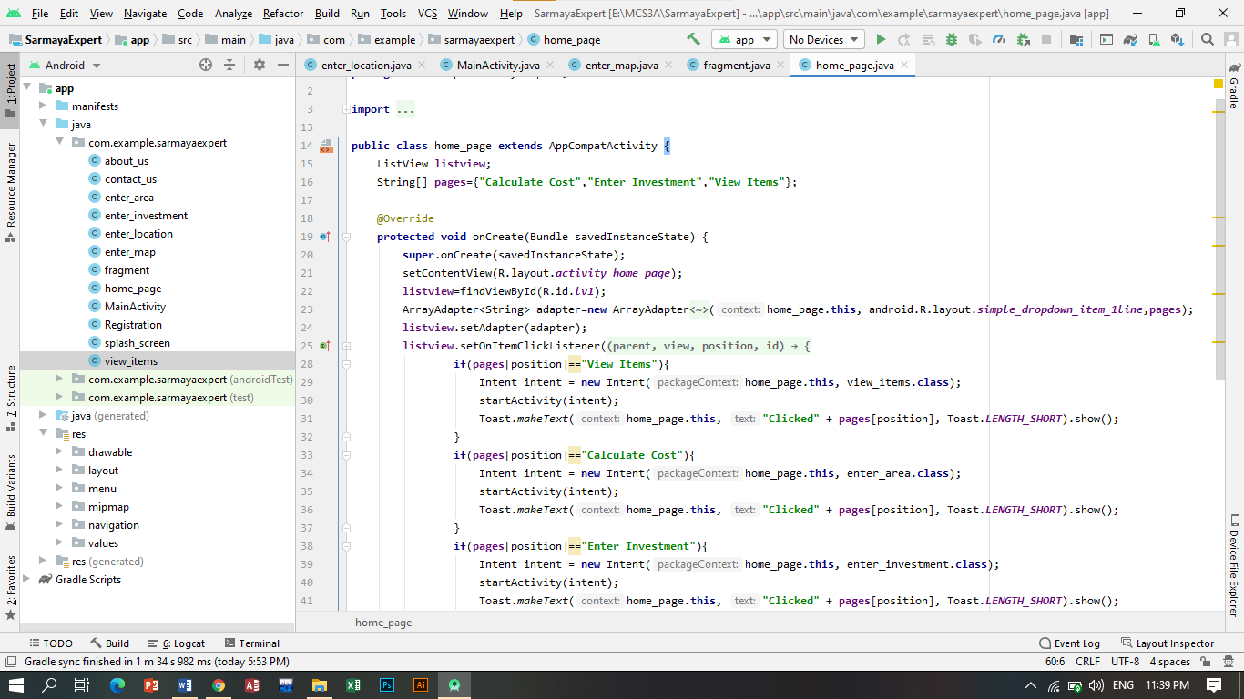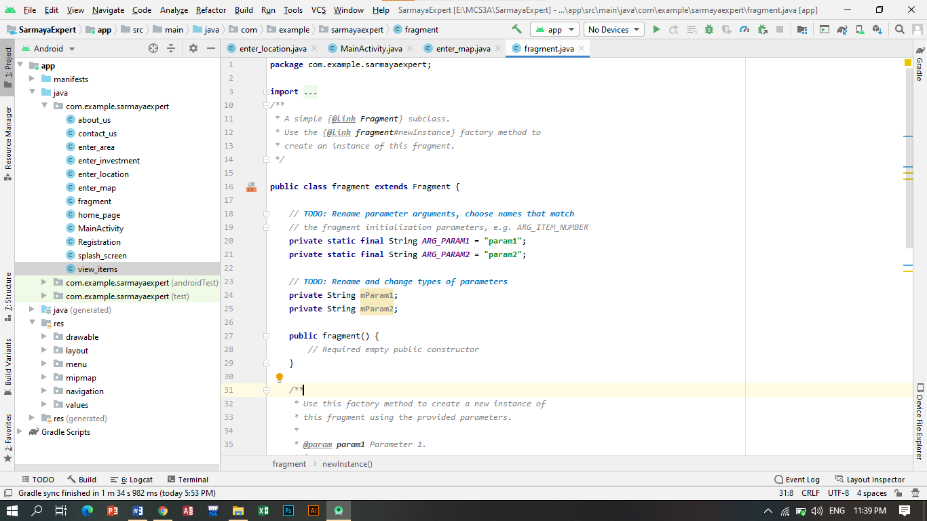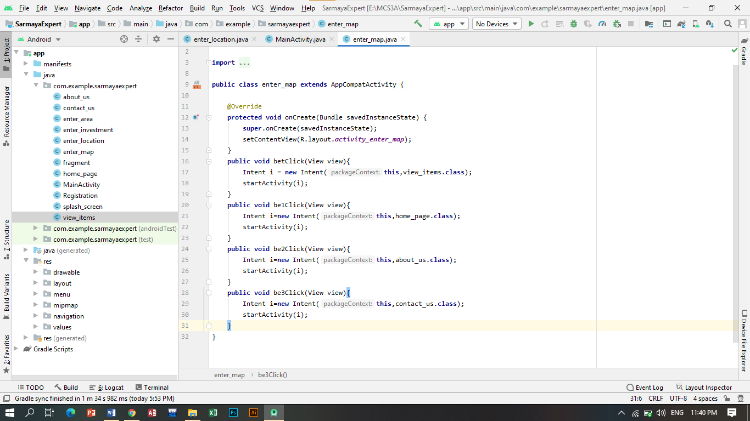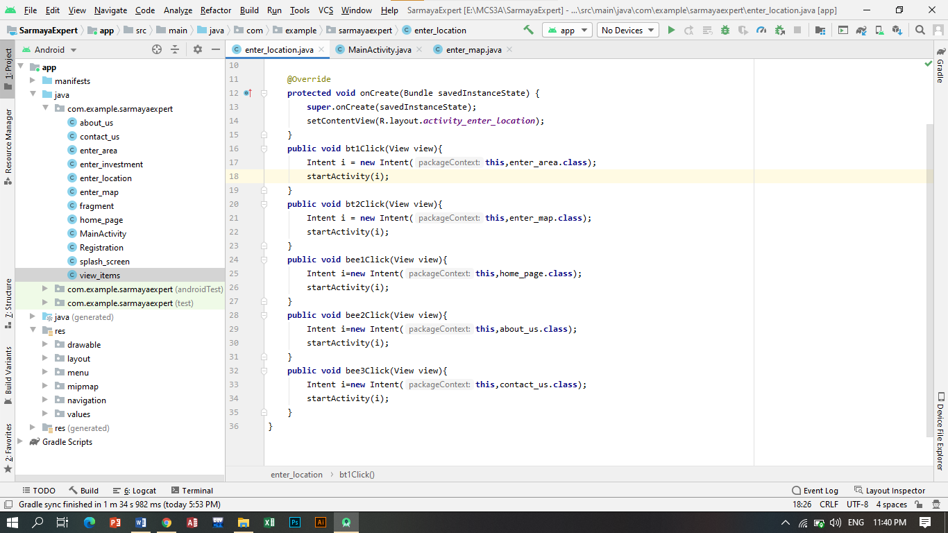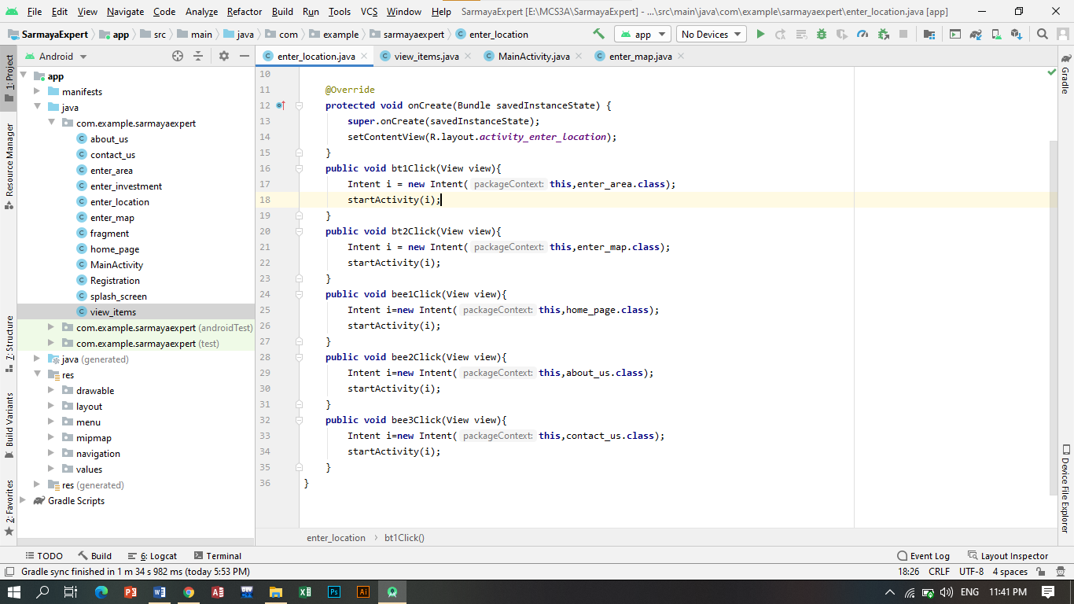

**Design:**

